**Smart Home**

**SMART PHONE**

HC05

MASTER MC2 UART

SLAVEMC1 SPI

ROOM 1

ROOM 2

ROOM 3

System construction:

The system is a smart controlled house and is consisted of 2 microcontroller based Bluetooth where we want to control home appliance wirelessly using Mobile App via Bluetooth.

• Two ECU’s Communicate with each other the first is a control ECU which takes the input from Bluetooth and send it to other ECu via SPI to interpret which action should be taken :

1. Atmega32 microcontroller
   * It is a hand held device.
   * Provides human interface for access and security control.
   * Wireless interface with the main ECU through Bluetooth interface.
   * Display on lcd.
2. Second microcontroller
   * Take signal and toggle led.
3. Temperature sensor :
   * Interfacing LM35 temperature sensors.
   * Provide commands to the AD ECU based on the sensor data and the received configuration from the MUGE ECU.
4. Actuator drive ECU (AD ECU):
   * Driving 5 RGB LEDs.

System operation:

1. On first system shall print a welcome message “Good Day” .
2. Two microcontrollers interface together by SPI communication protocol one of them is the master and other slave .
3. Master give me three option , display it on LCD and send it to slave using UART communication “connect bluetooth module (HC05) with smart phone or virtual terminal in protues” :
4. write 0 at smart phone toggle led1 at slave.

b- write 1 at smart phone toggle led2 at slave.

1. write 2at smart phone toggle led3 at slave.
2. I connect LM35 temperature sensor with microcontroller and display it on seven segment. If temp <22degree close air conditioner “buzzer” and if temp >24degree open air conditioner”led”.

**Schematic on protues:**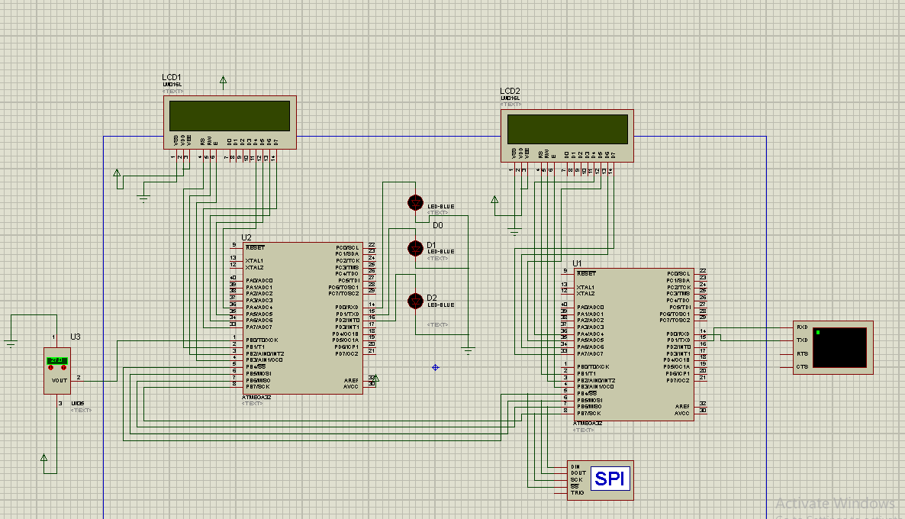

**layered Architecture:**

**HAL : Hardware ( lcd , 7segment,buzzer,led,sensor).**

# MCAL : Microcontroller Abstraction Layer

**I/O Drivers :(ADC Driver_ DIO Driver_ PORT Driver_ PWM Driver)**

**Communication Drivers: UART &SPI.**

**Microcontroller Drivers:**